PLATINUM SPONSOR - $2000
- Exhibit table in Exhibit Hall – 2 chairs and non-skirted table provided
- Exclusive sponsorship of a particular webinar or speaker
- 3 min. Transition/Break video ad played in a webinar
- Recognition at the beginning and throughout the convention
- Banner ad on website for 3 months ($399 value)
- Logo promotion on Facebook, LinkedIn and Twitter
- Full page ad in FPA’s magazine for TWO issues Florida Psychologist ($1100 value)
- 2 complimentary FPA Convention registrations (over $400 value)
- Lunches and snacks included

GOLD SPONSOR - $1000
- Exhibit table in Exhibit Hall – 2 chairs and non-skirted table provided
- Full page ad in FPA's magazine, Florida Psychologist ($575 value)
- Banner ad on website for 3 months ($399 value)
- Recognition during convention
- Logo promotion on Facebook, LinkedIn and Twitter
- 2 complimentary FPA Convention registration (over $400 value)
- Lunches and snacks included

SILVER SPONSOR - $500 (no exhibit table)
- Half page ad in FPA's magazine, Florida Psychologist ($375 value)
- Banner ad on website for 1 month ($150 value)
- Logo promotion on Facebook, LinkedIn and Twitter
- Recognition during convention
- 1 complimentary FPA Convention registration (over $200 value)

BRONZE SPONSOR - $250 (no exhibit table)
- Quarter page ad in FPA's magazine, Florida Psychologist ($275 value)
- Banner ad on website for 1 month ($150 value)
- Logo promotion on Facebook, LinkedIn and Twitter
- Recognition during convention

CONVENTION APP SPONSOR - $4000
- Exhibit table in Exhibit Hall – 2 chairs and non-skirted table provided
- Exclusive sponsorship of a particular webinar or speaker
- Permanent banner with logo on front page of convention app
- 3 min. Transition/Break video ad played in a webinar
- Recognition at the beginning and throughout the convention
- Banner ad on website for 6 months ($800 value)
- Logo promotion on Facebook, LinkedIn and Twitter
- Full page ad in FPA’s magazine for FOUR issues, Florida Psychologist ($2200 value)
- 2 complimentary FPA Convention registrations (over $400 value)
RECEPTION SPONSOR - $5000
The Saturday evening reception will include the FPA Annual Awards and is a fundraiser for the Psychologists of Florida Political Action Committee.

- Exhibit table in Exhibit Hall – 2 chairs and non-skirted table provided
- Exclusive recognition at the beginning of the reception
- 3 min. Transition/Break video ad played in a webinar
- Banner ad on website for 6 months ($800 value)
- Logo promotion on Facebook, LinkedIn and Twitter
- Full page ad in FPA’s magazine for FOUR issues, Florida Psychologist ($2200 value)
- 2 complimentary FPA Convention registrations (over $400 value)
- Complimentary drink tickets

BUILD YOUR OWN SPONSORSHIP
- $200 Banner ad on FPA’s website for 3 months ($399 value)
- $75 Banner ad on FPA’s website for 1 month ($150 value)
- $200 Full page ad in FPA’s magazine, Florida Psychologist Fall issue ($575 value)
- $150 Half page ad in FPA’s magazine, Florida Psychologist Fall issue ($375 value)
- $125 Quarter page ad in FPA’s magazine, Florida Psychologist Fall issue ($250 value)
- $25 Logo promotion on Facebook, LinkedIn and Twitter

TOTAL $ ____________

Tabletop exhibit space includes: 1 non-skirted 6-foot table and 2 chairs, lunch, Reception and breaks. Exhibitor will be recognized in the magazine, social media, and website.

Exhibit hall set-up: Saturday, Sept. 13, 9:00 am
Exhibit hall tear-down: Saturday evening after the reception OR Sunday, Sept. 14, 1:00 pm

Exhibit times are tentative until presentation schedule is confirmed. Only one (1) entity/company shall occupy each exhibit space.

Door Prizes
Door prizes are another great way of attracting attendees to the exhibit hall and keeping them there. Please indicate on the form if you would like to provide a door prize during the trade show. We hope you will be able to participate and help add excitement to the 2025 convention!

Booth assignments - LIMITED TO 10 EXHIBITORS
Booth assignments are granted according to when application and payment are received. The sooner the better.

Exhibit contact person
When arriving, please contact Kim Campbell on her cell phone at 850-556-3059. She will be your contact throughout the convention.

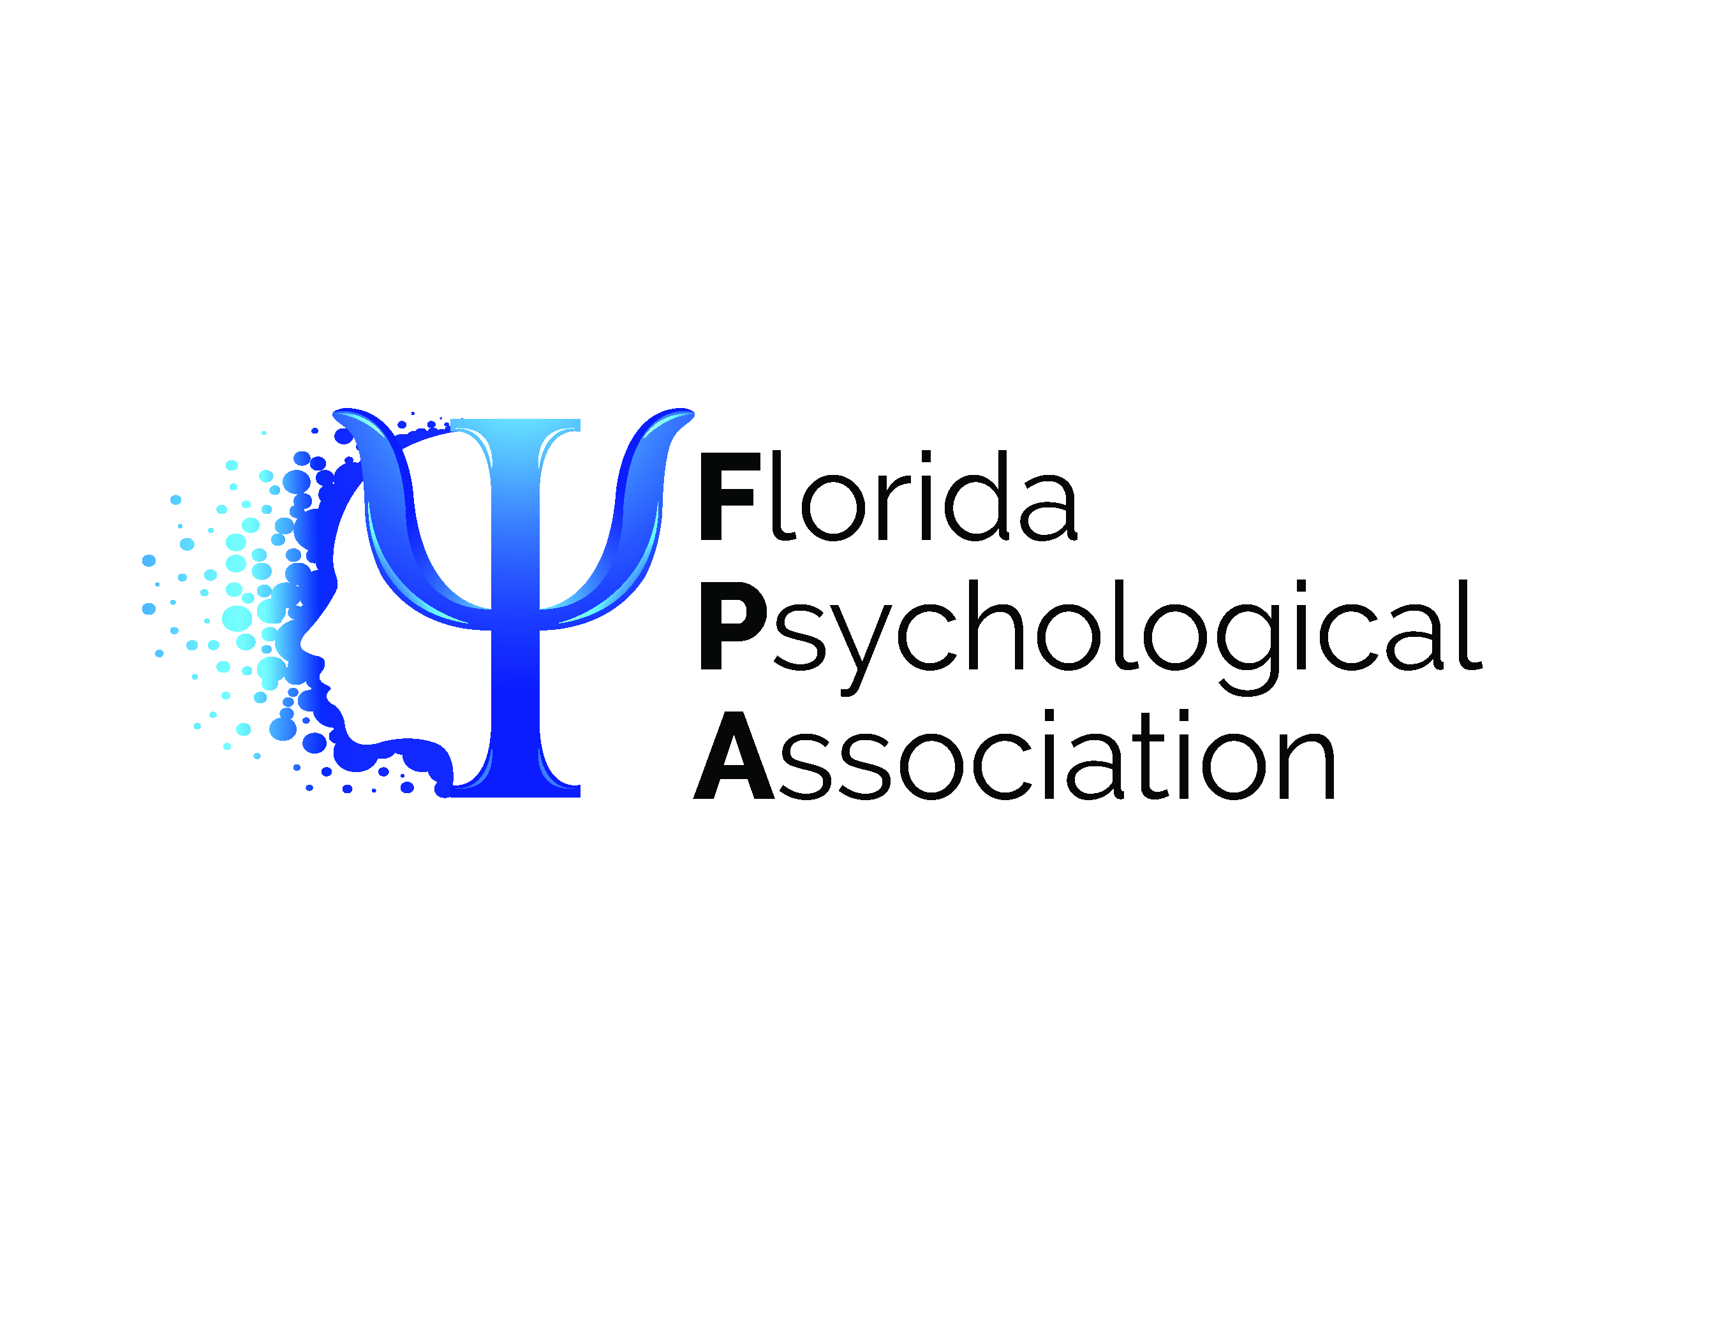

2025 Hybrid Convention
September 13-14, 2025

EXHIBITOR AND SPONSORSHIP REGISTRATION

Company: ______________________________________________________________________________
Contact: ________________________________________________________________________________
Phone: _________________________________________________________________________________
Email: __________________________________________________________________________________
We will donate a door prize. (door prize description)__________________________________________
❒ Platinum Sponsor Package - $2,000  Silver Sponsor Package - $500
❒ Gold Sponsor Package - $1000  Bronze Sponsor Package - $250
❒ Convention App Sponsor Package - $4000  Build Your Own Sponsorship $_______
❒ Reception Sponsor Package - $5000

❒ Check (payable to FPA)  Visa  MC  Amex  Discover

Name on credit card: ____________________________________________________________
Card #: _________________________________ Expiration: _________** Security Code_________
Billing Address: _____________________________________________________________________
City: ___________________________________________ State: ________ Zip Code: ____________
Signature: _____________________________________________________________________________________

Contract due to Kim Campbell by September 1, 2025

By Mail: Florida Psychological Association
PO Box 7416; Tallahassee, FL 32314
By fax: (850) 344-9085
By email: kim@flapsych.com
(**Security code for V/MC/D is 3-digit # on the back of the card. Amex has 4-digit # on the front of the card.)

